Documentation Microservice Reset

Goal: Allow to us to reset the Boolean in our database MySQL (set the value to 0).

Main.go file:

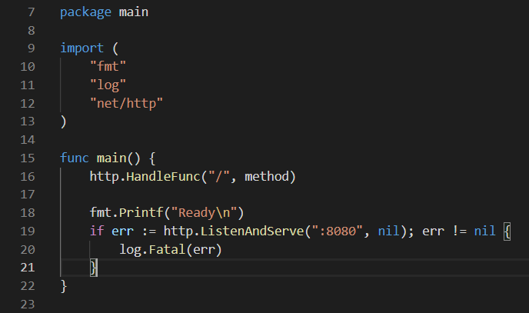



Here, we define the URL that we are going to work on.



Here, we define the port that we are going to listen on our web server.

In the main function, we declare our REST API and our web server.

Method.go file:

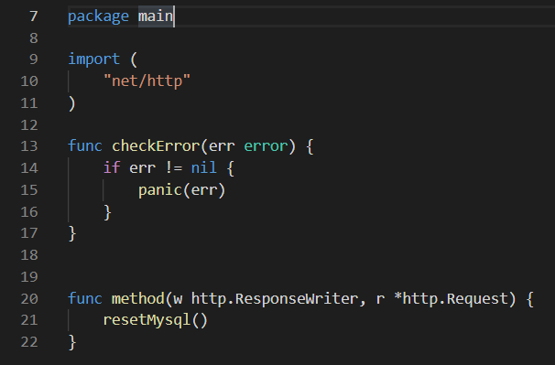

Here, we call the method function to call our reset code.

The checkError function allows to us to check if there is an error in our method.

Reset.go file:

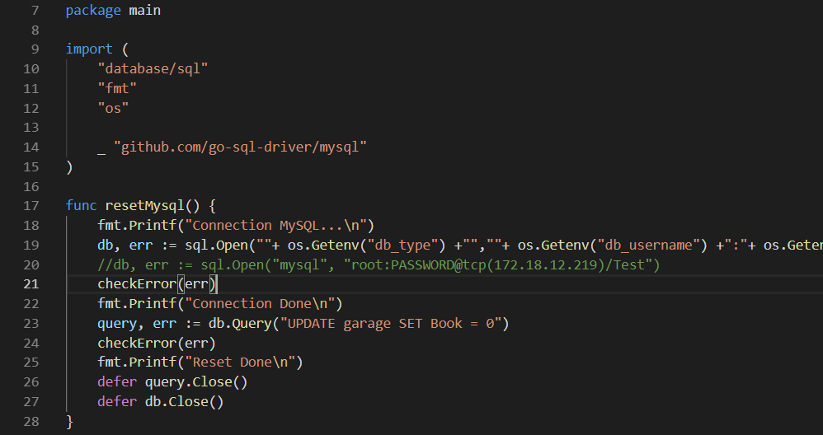

Line 19: db, err := sql.Open(""+ os.Getenv("db_type") +"",""+ os.Getenv("db_username") +":"+ os.Getenv("db_password") +"@tcp("+ os.Getenv("db_ip") +")/"+ os.Getenv("db_name") +"")

It is a classic mysql connection, we use some environment variable to connect to our database. The env variable are set in our dockerfile just below.

Dockerfile:

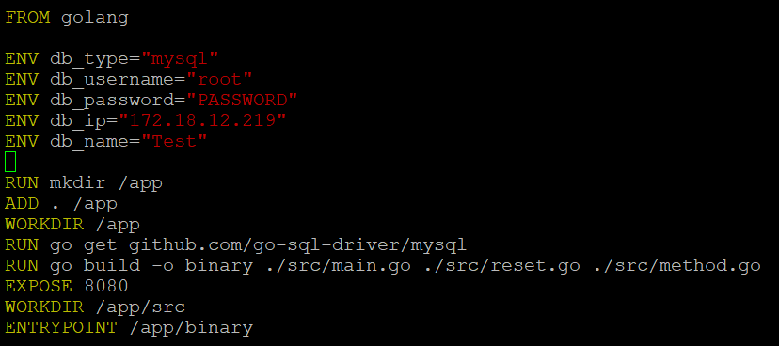

This Microservice allow to us to reset our Boolean. With this microservice, when all the cars are book, we can reset them to 0 and display them with the booking microservice.

There is no HTML page, it’s just some code that we launch when we redirect to the Ip address.

Ip: 172.18.12.219:5555.